National Motto Curriculum Plan
Approximately 10 minutes

Q: If I mention names like George Washington, Thomas Jefferson, Benjamin Franklin, John Hancock, and James Madison, what comes to mind? What did these men do?
A: They were some of our country’s Founding Fathers and they gave us our present governmental system.

Q: What type of governmental system did they give us?
A: A Constitutional Republic

Q: What’s a Constitutional Republic?
A: It’s a system where a written constitution is the ultimate law of the land and all new laws must be measured against it. A republic is a system where we democratically elect a set of representatives who as a smaller body vote for us in making those new laws.

Q: What else is unique about our American Republic?
A: Our Founding Fathers believed that all men are created equal and that they are endowed by their Creator with certain unalienable rights, including life, liberty, and the pursuit of happiness. They also believed that the purpose of government was to protect those rights, and those rights can’t be taken away by government.

Draw the following on the board

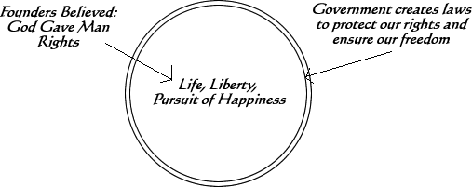

Q: Who knows what our original National Motto was?
A: E PLURIBUS UNUM (which means “Out of many, one”). Our Founders chose this as their motto signifying the 13 original states were united in one country, America.

Q: What is our current National Motto and why was it changed?
A: “In God We Trust.” Our national motto was changed in 1956 during our country’s conflict with Communism. Communists don’t believe in God, promote Atheism as their religion, and believe all rights come from the government. Our country’s leaders wanted to make sure everyone knew that this country believed and trusted in a power greater than government, namely God, who endowed us with rights that couldn’t be taken away, so they changed the national motto to reflect this belief.

This poster was donated to our classroom to serve as a reminder of our national motto.

