Dear Teacher,
Thank you for the time and effort you put into teaching our children. Yours is a vital role in preparing them for their futures. As a concerned parent, I have studied the math issue by spending hundreds of hours over the last year and a half to objectively understand what is being done to our children. At the start of this school year I would like to point out a couple of things.
Alpine School District has completely ignored the overwhelming evidence that Investigations, Connected, and Interactive math are complete failures as programs and condemned by hundreds of leading mathematicians. ASD has not been able to produce a single study which supports their decision to implement them. To the contrary, they ignore the largest independent education study ever produced which clearly shows evidence contradicting their views. This graph from Project Follow-Through and additional information can be further explained by going to:

http://www.oaknorton.com/imathresults34.cfm

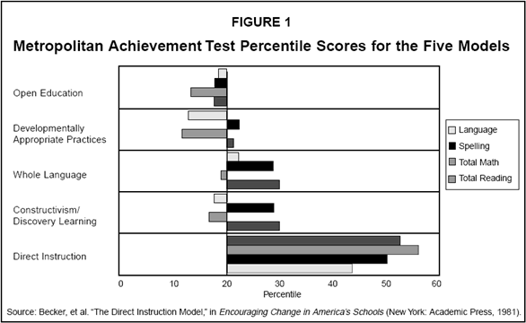
“Until education becomes the kind of profession that reveres evidence, we should not be surprised to find its experts dispensing unproven methods, endlessly flitting from one fad to another. The greatest victims of these fads are the very students who are most at risk.”
--Dr. Douglas Carnine, Univ. of Oregon

This year, please make your emphasis on traditional math and ignore the pressure to use NCTM standards which have proven to be nothing more than a destructive fad. For the real story on NCTM standards, please check out this page:
http://www.nychold.com/myths-050504.html

Please recognize the desire of thousands of parents to not have to supplement and tutor their children at home because of the great weaknesses of Investigations, Connected, and Interactive math.

Sincerely,

Oak Norton
www.oaknorton.com

